- The Bank of England's Monetary Policy Committee narrowly voted to keep Bank Rate at 4% today but laid the ground to cut again in one of the next two meetings. We lean towards a December cut, given this month's Budget is likely to significantly tighten fiscal policy.
- Governor Andrew Bailey was again the swing voter in November. Though he voted to hold, his statement was dovish and the bar to him switching vote looks low. We think a fall in inflation before the next meeting and a front-loading of fiscal tightening would likely tip the balance.
- Most of the MPC think policy is still restrictive and signalled that the risks to inflation have shifted from the upside into balance. We expect activity to disappoint the MPC's expectations next year, resulting in two 25bps cuts that lower Bank Rate to 3.25% by end-2026.
The Bank of England's Monetary Policy Committee voted 5-4 to hold Bank Rate at 4% at today's meeting. The four dissenters – Sarah Breedon, Swati Dhingra, Dave Ramsden, and Alan Taylor – preferred a 25bp cut.
Changes to the minutes meant for the first time each member presented a paragraph summarising their views. Governor Andrew Bailey was the swing voter, and his paragraph suggested it was a close call. He felt that "upside risks to inflation have become less pressing" and that "the latest CPI data were promising". This gave the clear impression that Bailey will be willing to switch votes if headline inflation continues to fall.
This leaves a December rate cut very much in play. Two more inflation prints will be released before that meeting, but they may not provide a clear steer. Using the BoE's staff forecast as a benchmark, we think the October figure will come in below expectations and November will be higher (Chart 1). But both are likely to be lower than September's, suggesting more progress on the disinflation front.
We think the Budget on November 26 is likely to prove key. It looks increasingly likely that the Chancellor will tighten fiscal policy significantly, and that a decent chunk of the measures will be front-loaded. If these assumptions prove correct, we think the next rate cut will come in December, rather than February. But it's likely to be another very close call with the committee deeply divided on the outlook for inflation.
Chart 1: Like the BoE, we think inflation will fall before the December meeting
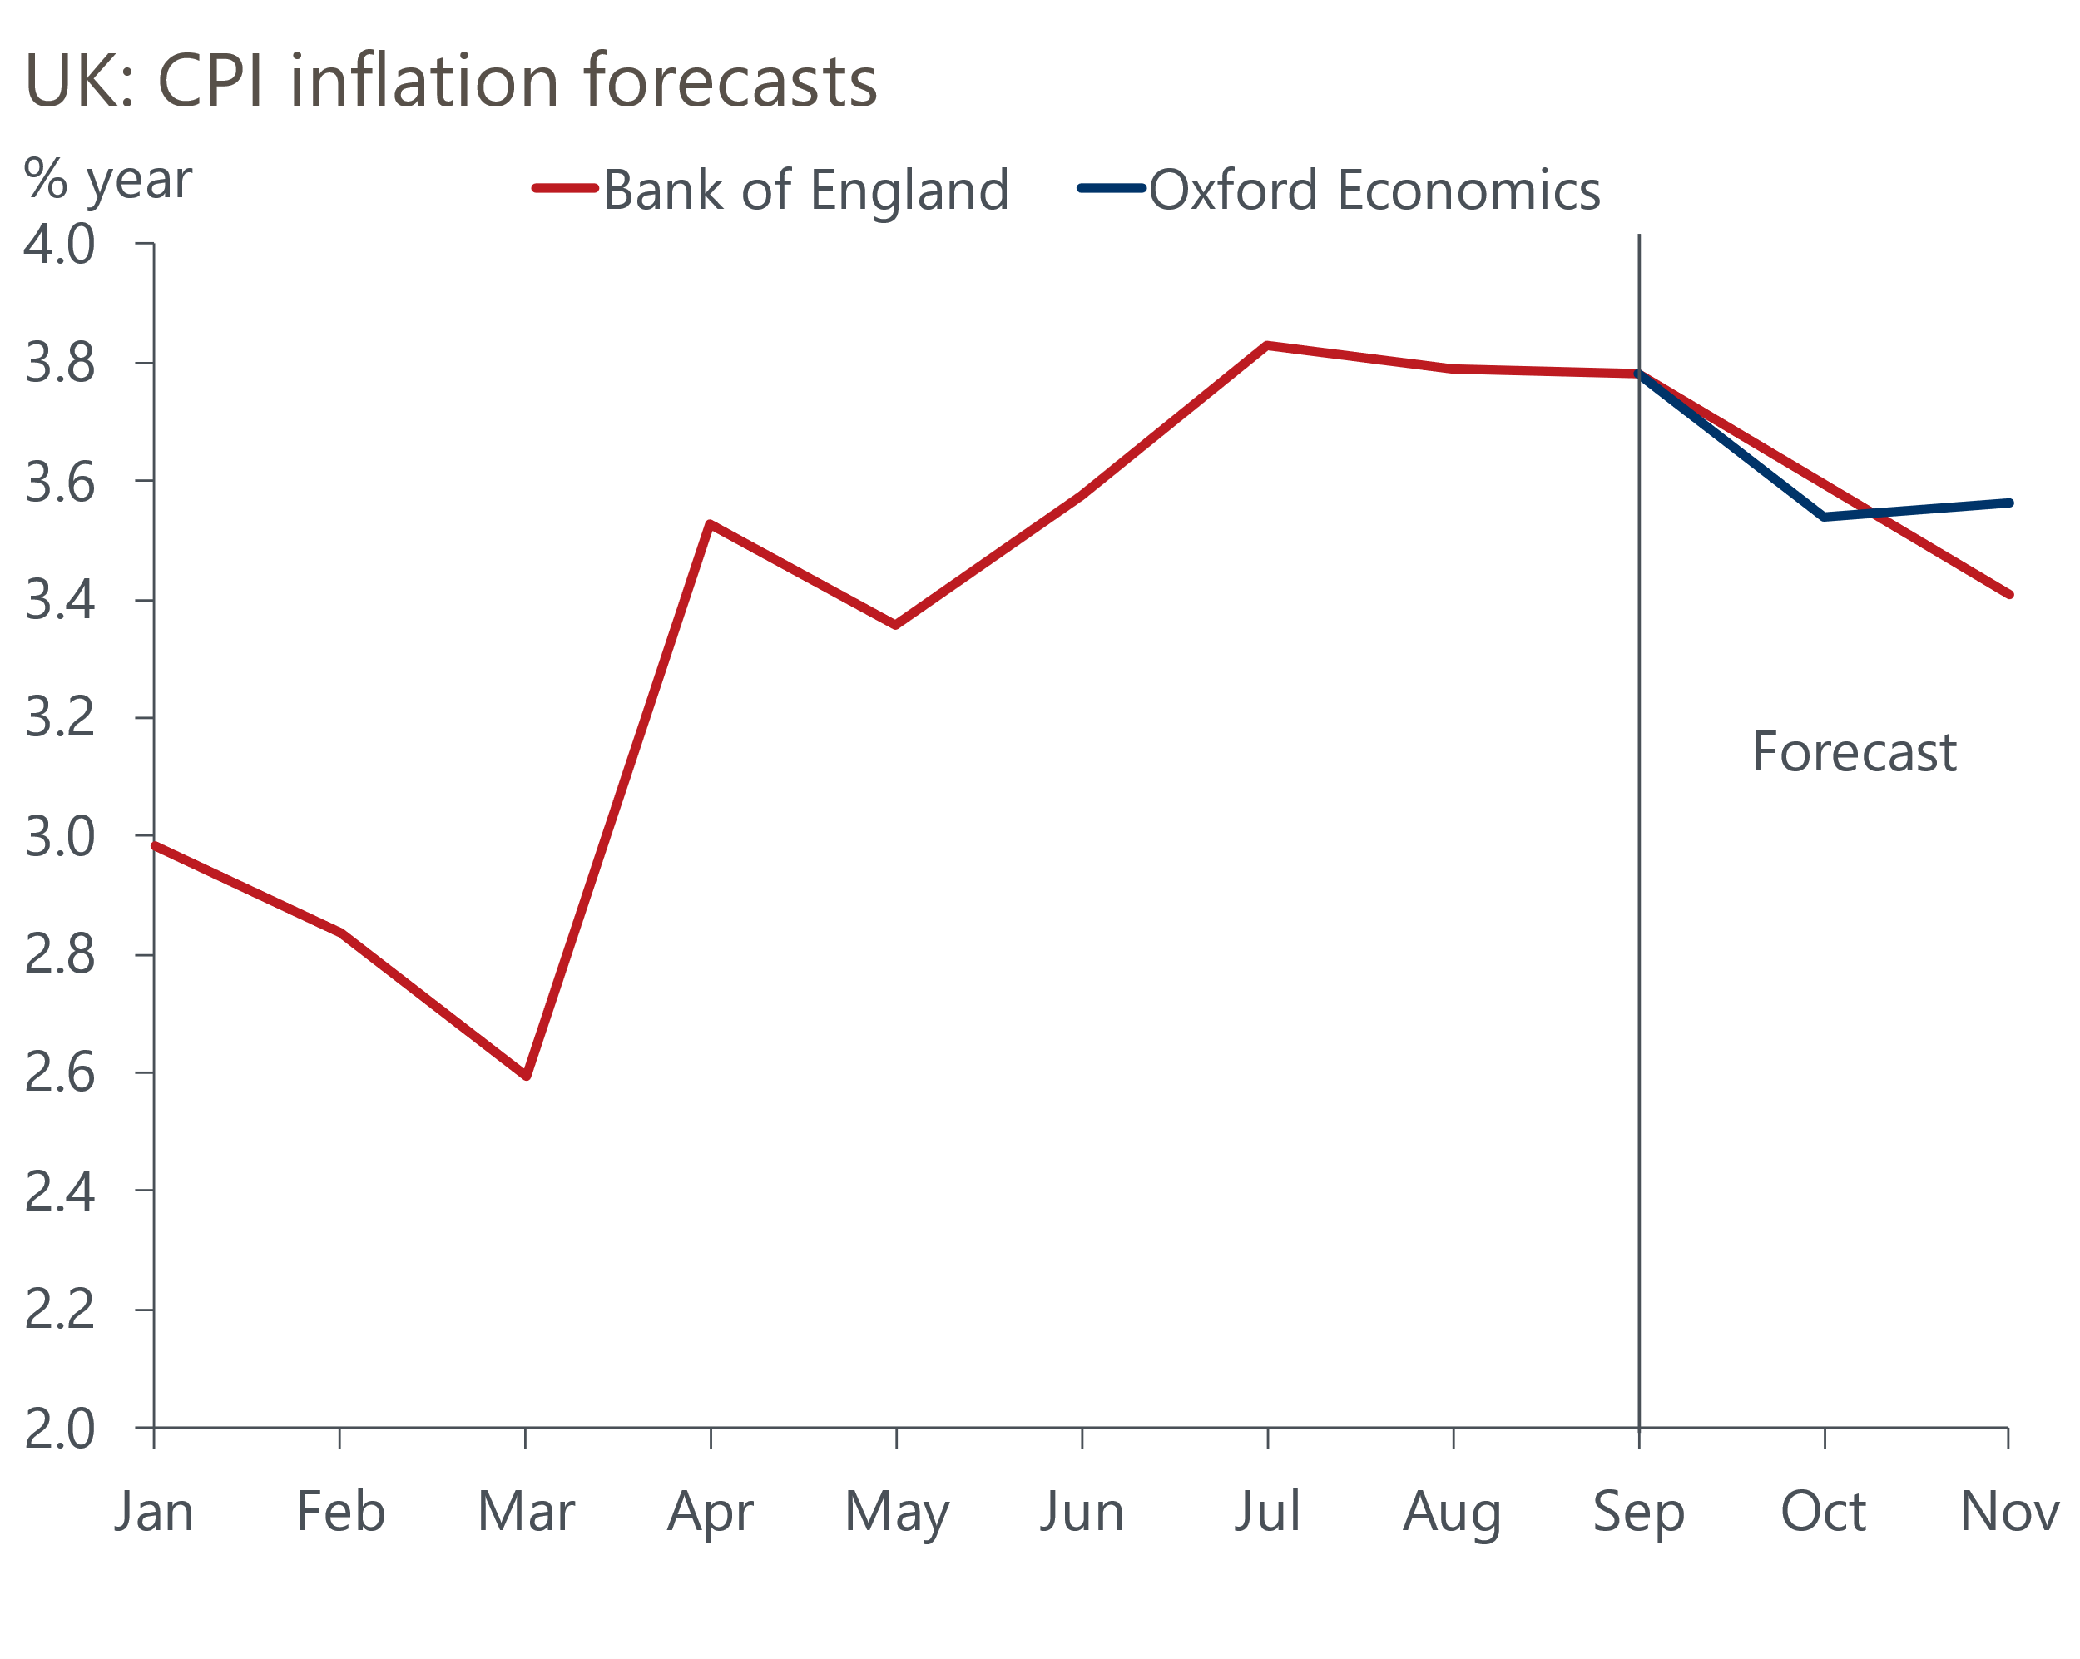
Sources: Oxford Economics, Bank of England

The MPC's core messages were first, that Bank Rate is likely to be cut further, provided disinflation continues, and second, that the risks to the inflation outlook have become more balanced. The risk from greater inflation persistence is less pronounced and the risk from weaker demand more apparent. But the individual statements from MPC members showed a wide range of views on the balance of risks.
The Monetary Policy Report presented two scenarios: one in which high past inflation continues to affect wage and price setting in the future; and another in which weak demand causes inflationary pressures to fade more quickly, driven by consumer spending weakness. These scenarios were presented relative to a central forecast, which most of the MPC consider to be a "reasonable baseline" (Chart 2).
Chart 2: MPC members back a range of different inflation scenarios
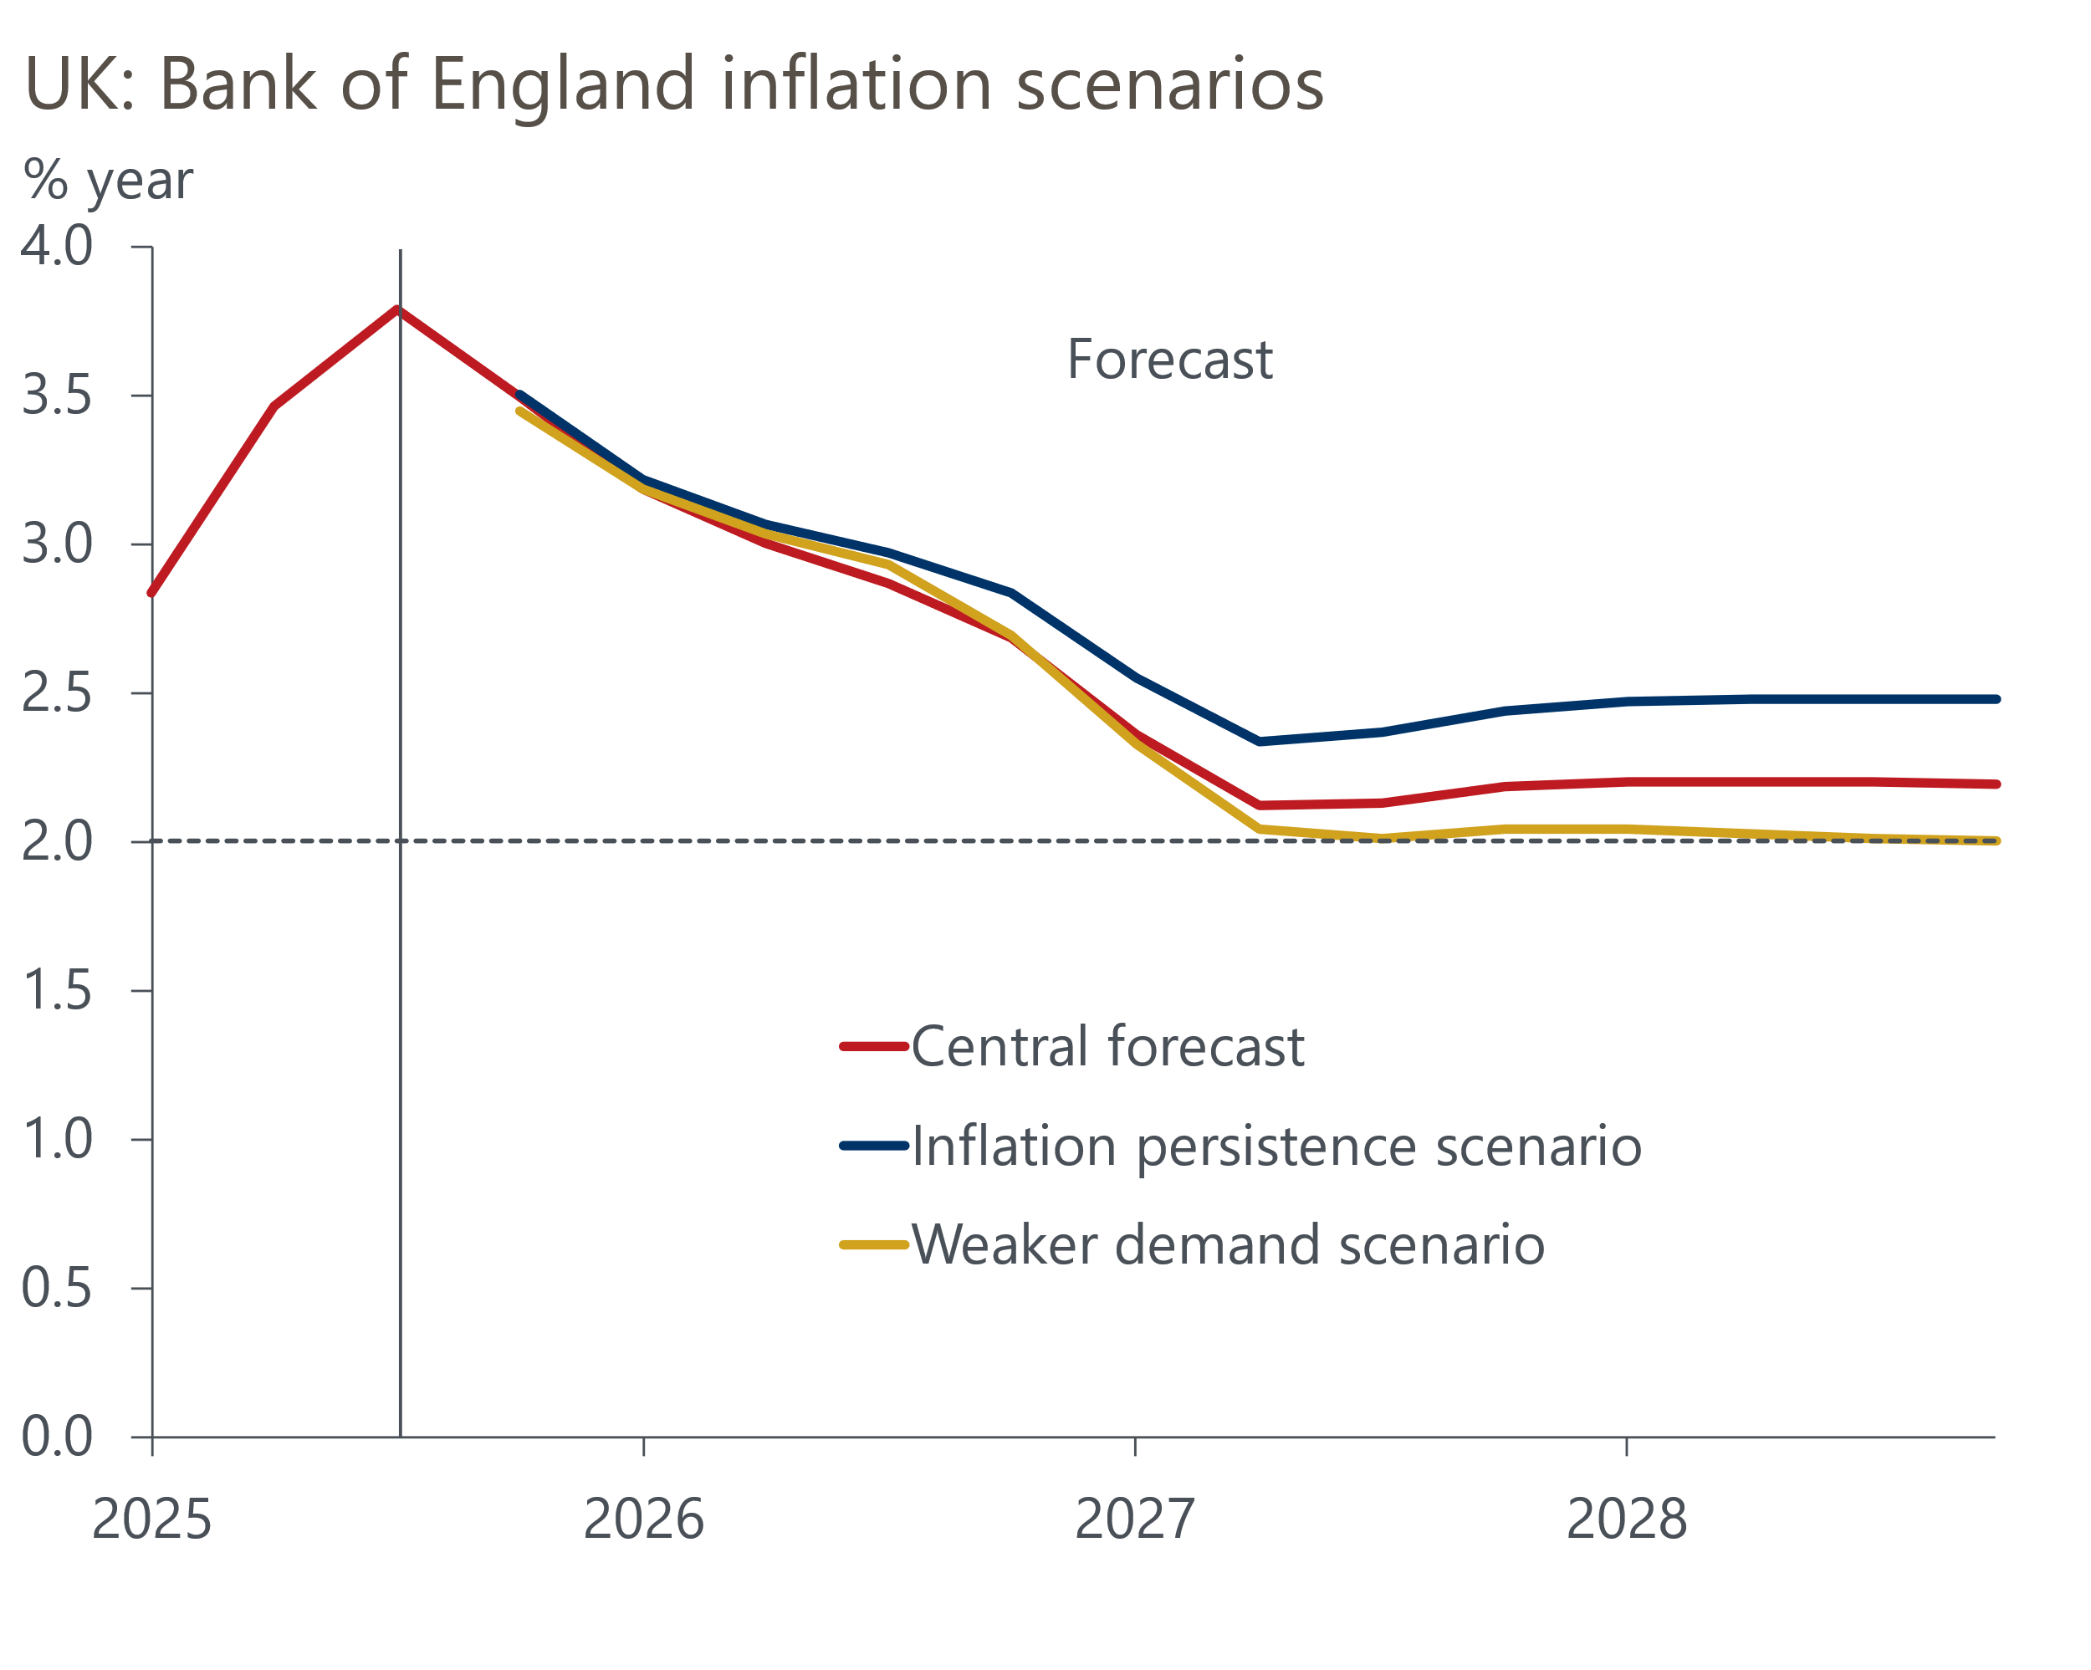
Source: Bank of England
The paragraphs of individual members suggested at least two members (Taylor and Dhingra) put the highest weight on an outcome closest to the downside scenario, whereas three (Megan Greene, Catherine Mann, and Huw Pill) cited concerns about elevated inflation expectations that echoed the upside scenario. Clare Lombardelli shared those worries, while also acknowledging the downside risks from weak consumption.
This wide divergence of views suggests that votes are likely to remain close for the foreseeable future, with Bailey likely to continue to act as the swing voter. It was notable that Bailey effectively endorsed market pricing in his paragraph – coming into the November meeting, this implies a little over two 25bps rate cuts by the end of 2026.
We think activity is likely to surprise the MPC on the downside over the coming year, reflecting the large drag from fiscal policy – both the measures already in place and those likely to be introduced on November 26. So after a December cut, we expect the MPC to cut twice more next year, lowering Bank Rate to 3.25% by the end of 2026. This is 25bps lower than our previous forecast.

